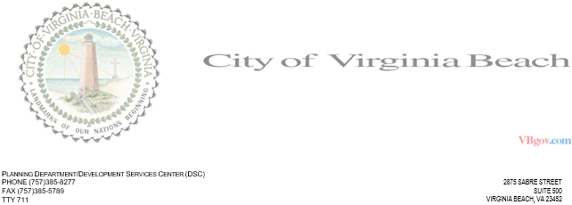

INTER-OFFICE MEMORANDUM **DATE:** 02/05/2021 **TO:** fdsa **FROM:** travis **SUBJECT:** fdsa  
 DSC Engineering Review Comments  
 DSC File: foo

DSC cannot approve the project at this time. The following comments must first be addressed:  
  
1: Provide silt fence around the extents of disturbance. ((VESCH 7.12).)